**WITH NOISE AND WITH FILTER FUZZY**

**Image set:**

|  |
| --- |
| **Image 1:-0.1 % Noise** |

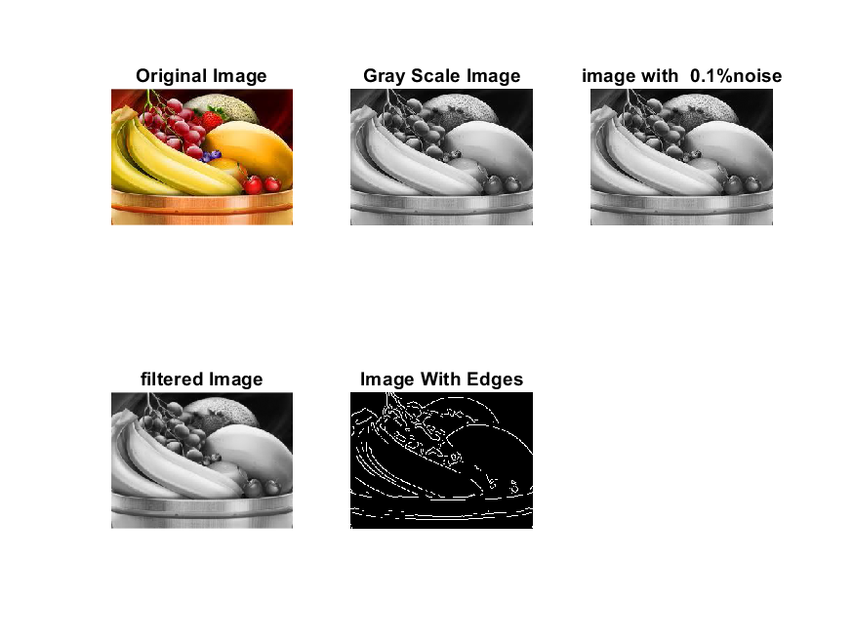

**Image 2:-10 % Noise**

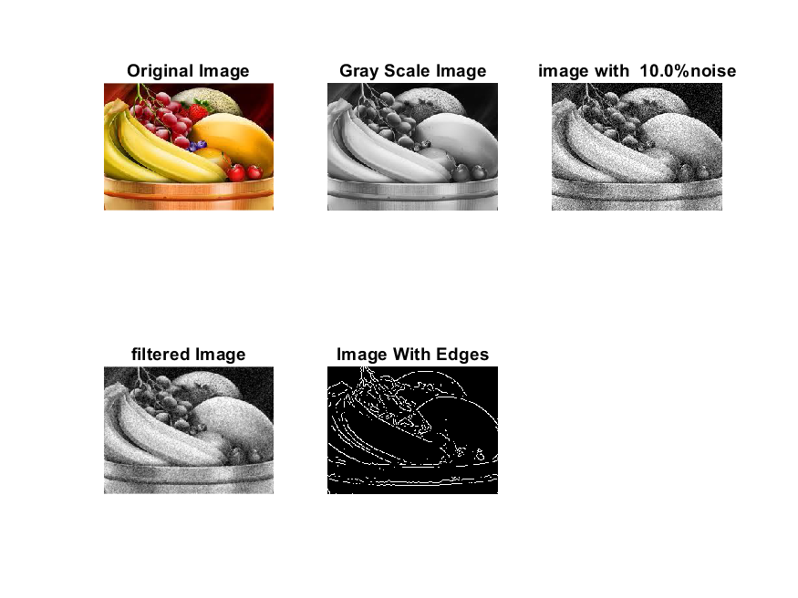

**Image 3:-20 % Noise**

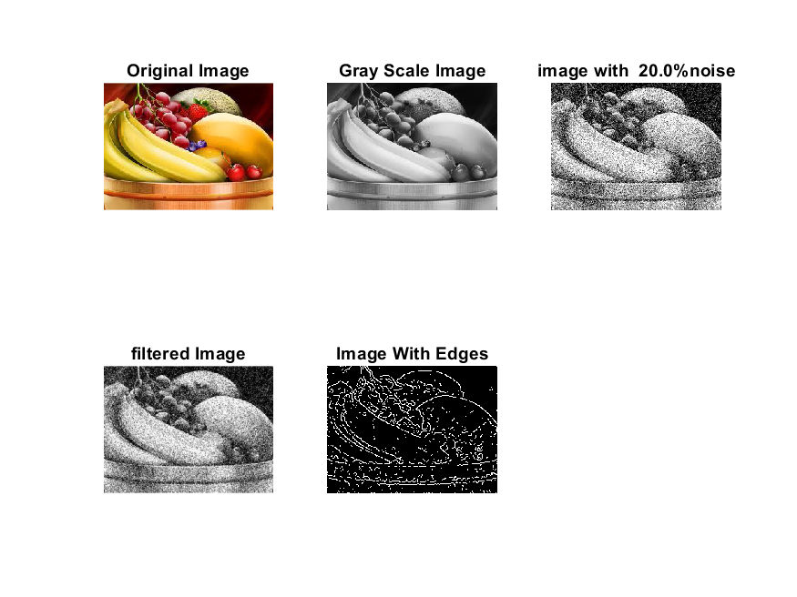

**Image 4:-30 % Noise**

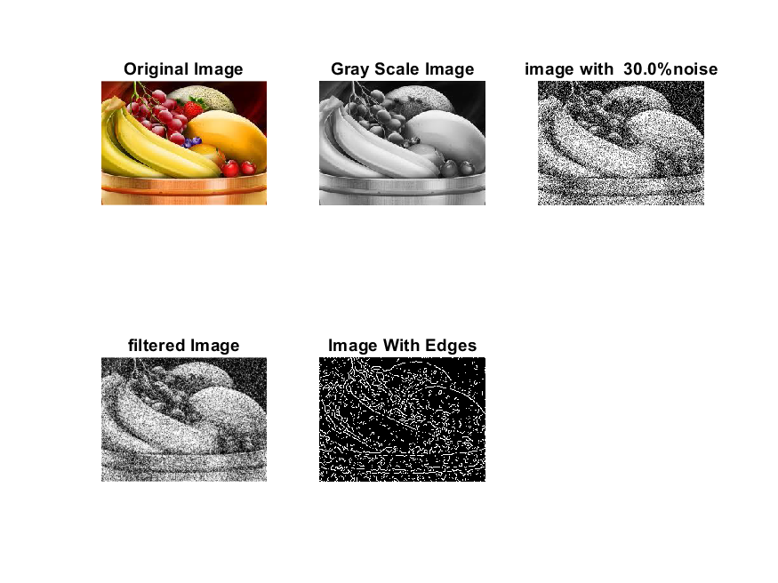

|  |
| --- |
| **Image 5:-40 % Noise** |

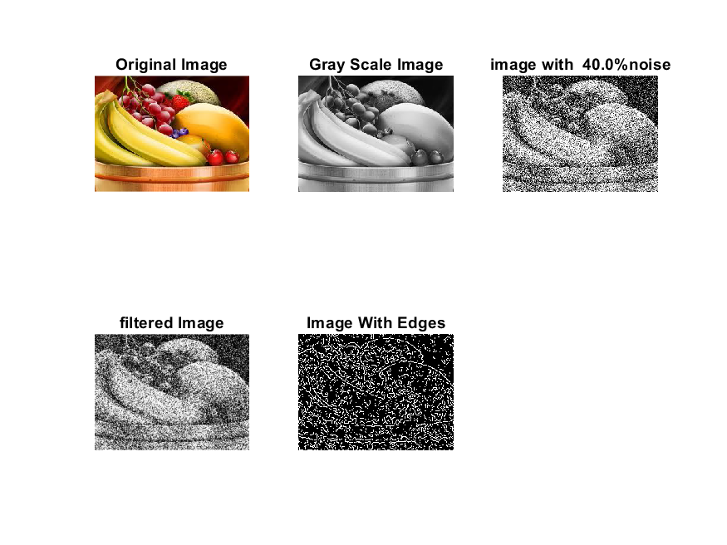

**Image 6:-50 % Noise**

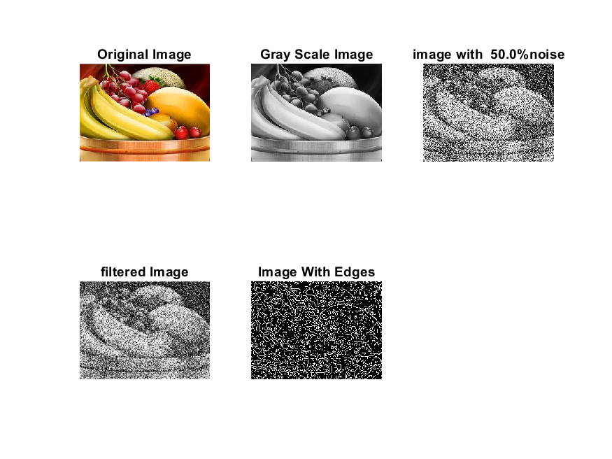

**Image 7:-60 % Noise**

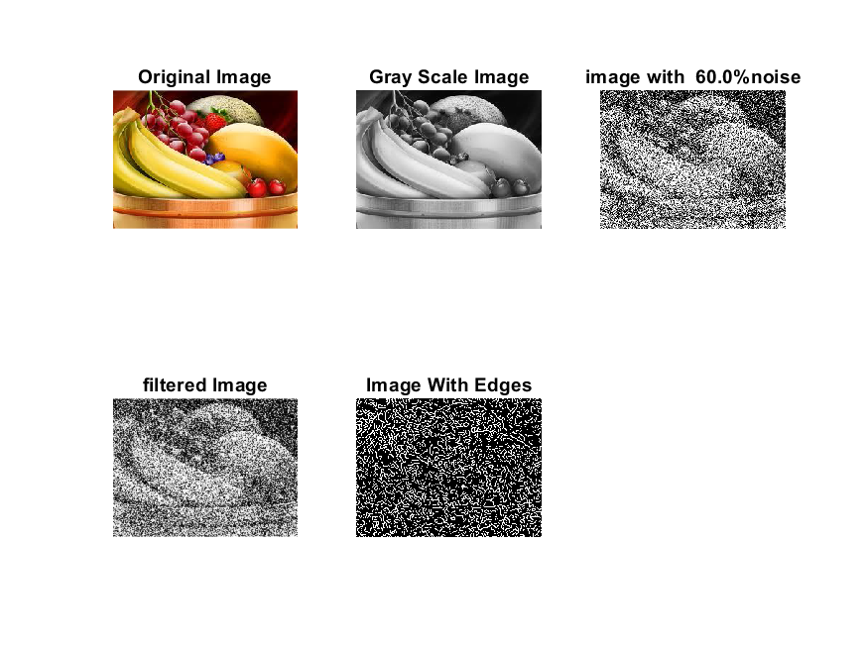

**Image 8:-70 % Noise**

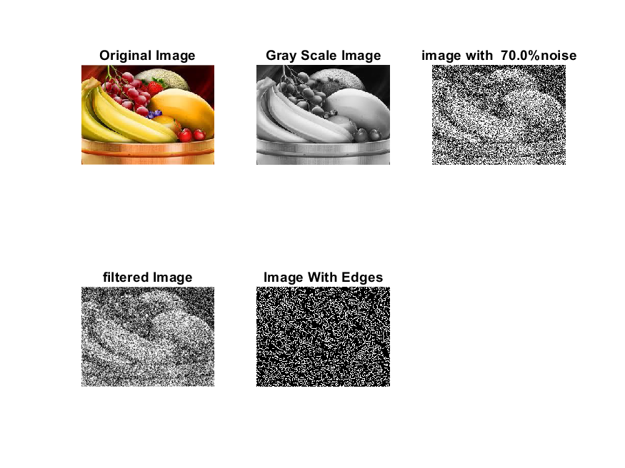

**Image 9:-80 % Noise**

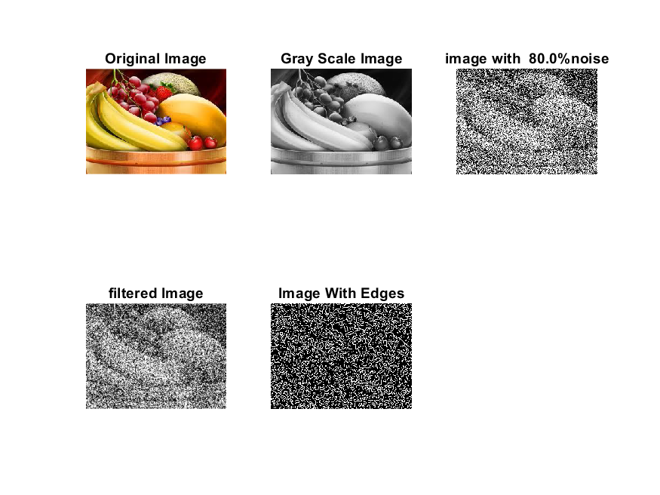

**DATA FILES**

**Image 1:-Noise0.1**

Original image ideal values:

IM1 image entropy:3.668721e-01

IM1 image mean:0.070254

Ground truth image entropy:0.815119

Ground truth image mean:0.252438

entropy between imt and im1 :0.775240

MSE between imt and im1 :0.274649

Average Difference between imt and im1 :0.182184

Maximum Difference between imt and im1 :1.000000

True Positive values:1207.000000

False Positive values: 2323.000000

True Negative values:35239.000000

False Negative values:11477.000000

Accuracy value: 0.725351

F Measure values:0.148884

Peak Signal-to Noise Ration value: 5.612224

Signal-to Noise Ration value: -5.554815

percentage of pixels that were correctly detected (Pco): 0.095159

The percentage of pixels that were not detected (Pnd):0.904841

the percentage of false alarm: (Pfa):0.183144

Euclidean Distance Value :8.613636

**Image 2:-Noise10**

Original image ideal values:

IM1 image entropy:3.896664e-01

IM1 image mean:0.076484

Ground truth image entropy:0.815119

Ground truth image mean:0.252438

entropy between imt and im1 :0.771129

MSE between imt and im1 :0.276221

Average Difference between imt and im1 :0.175954

Maximum Difference between imt and im1 :1.000000

True Positive values:1324.000000

False Positive values: 2519.000000

True Negative values:35043.000000

False Negative values:11360.000000

Accuracy value: 0.723779

F Measure values:0.160223

Peak Signal-to Noise Ration value: 5.587433

Signal-to Noise Ration value: -5.185858

percentage of pixels that were correctly detected (Pco): 0.104383

The percentage of pixels that were not detected (Pnd):0.895617

the percentage of false alarm: (Pfa):0.198597

Euclidean Distance Value :9.525183

**Image 3:-Noise20**

Original image ideal values:

IM1 image entropy:4.863786e-01

IM1 image mean:0.105561

Ground truth image entropy:0.815119

Ground truth image mean:0.252438

entropy between imt and im1 :0.758853

MSE between imt and im1 :0.291685

Average Difference between imt and im1 :0.146877

Maximum Difference between imt and im1 :1.000000

True Positive values:1666.000000

False Positive values: 3638.000000

True Negative values:33924.000000

False Negative values:11018.000000

Accuracy value: 0.708315

F Measure values:0.185235

Peak Signal-to Noise Ration value: 5.350860

Signal-to Noise Ration value: -3.786527

percentage of pixels that were correctly detected (Pco): 0.131347

The percentage of pixels that were not detected (Pnd):0.868653

the percentage of false alarm: (Pfa):0.286818

Euclidean Distance Value :12.205655

**Image 4:-Noise30**

Original image ideal values:

IM1 image entropy:6.176097e-01

IM1 image mean:0.153127

Ground truth image entropy:0.815119

Ground truth image mean:0.252438

entropy between imt and im1 :0.739245

MSE between imt and im1 :0.318354

Average Difference between imt and im1 :0.099311

Maximum Difference between imt and im1 :1.000000

True Positive values:2191.000000

False Positive values: 5503.000000

True Negative values:32059.000000

False Negative values:10493.000000

Accuracy value: 0.681646

F Measure values:0.215036

Peak Signal-to Noise Ration value: 4.970901

Signal-to Noise Ration value: -2.171041

percentage of pixels that were correctly detected (Pco): 0.172737

The percentage of pixels that were not detected (Pnd):0.827263

the percentage of false alarm: (Pfa):0.433854

Euclidean Distance Value :16.322829

**Image 5:-Noise40**

Original image ideal values:

IM1 image entropy:7.023558e-01

IM1 image mean:0.190423

Ground truth image entropy:0.815119

Ground truth image mean:0.252438

entropy between imt and im1 :0.722755

MSE between imt and im1 :0.338813

Average Difference between imt and im1 :0.062015

Maximum Difference between imt and im1 :1.000000

True Positive values:2614.000000

False Positive values: 6954.000000

True Negative values:30608.000000

False Negative values:10070.000000

Accuracy value: 0.661187

F Measure values:0.234945

Peak Signal-to Noise Ration value: 4.700399

Signal-to Noise Ration value: -1.224351

percentage of pixels that were correctly detected (Pco): 0.206086

The percentage of pixels that were not detected (Pnd):0.793914

the percentage of false alarm: (Pfa):0.548250

Euclidean Distance Value :19.649472

**Image 6:-Noise50**

Original image ideal values:

IM1 image entropy:7.634564e-01

IM1 image mean:0.221809

Ground truth image entropy:0.815119

Ground truth image mean:0.252438

entropy between imt and im1 :0.708957

MSE between imt and im1 :0.356586

Average Difference between imt and im1 :0.030629

Maximum Difference between imt and im1 :1.000000

True Positive values:2956.000000

False Positive values: 8189.000000

True Negative values:29373.000000

False Negative values:9728.000000

Accuracy value: 0.643414

F Measure values:0.248101

Peak Signal-to Noise Ration value: 4.478362

Signal-to Noise Ration value: -0.561762

percentage of pixels that were correctly detected (Pco): 0.233050

The percentage of pixels that were not detected (Pnd):0.766950

the percentage of false alarm: (Pfa):0.645617

Euclidean Distance Value :22.347793

**Image 7:-Noise60**

Original image ideal values:

IM1 image entropy:8.048599e-01

IM1 image mean:0.245990

Ground truth image entropy:0.815119

Ground truth image mean:0.252438

entropy between imt and im1 :0.698391

MSE between imt and im1 :0.370617

Average Difference between imt and im1 :0.006448

Maximum Difference between imt and im1 :1.000000

True Positive values:3211.000000

False Positive values: 9149.000000

True Negative values:28413.000000

False Negative values:9473.000000

Accuracy value: 0.629383

F Measure values:0.256429

Peak Signal-to Noise Ration value: 4.310752

Signal-to Noise Ration value: -0.112378

percentage of pixels that were correctly detected (Pco): 0.253154

The percentage of pixels that were not detected (Pnd):0.746846

the percentage of false alarm: (Pfa):0.721302

Euclidean Distance Value :24.354596

**Image 8:-Noise70**

Original image ideal values:

IM1 image entropy:8.182833e-01

IM1 image mean:0.254468

Ground truth image entropy:0.815119

Ground truth image mean:0.252438

entropy between imt and im1 :0.697132

MSE between imt and im1 :0.377901

Average Difference between imt and im1 :-0.002030

Maximum Difference between imt and im1 :1.000000

True Positive values:3241.000000

False Positive values: 9545.000000

True Negative values:28017.000000

False Negative values:9443.000000

Accuracy value: 0.622099

F Measure values:0.254495

Peak Signal-to Noise Ration value: 4.226223

Signal-to Noise Ration value: 0.034785

percentage of pixels that were correctly detected (Pco): 0.253480

The percentage of pixels that were not detected (Pnd):0.738542

the percentage of false alarm: (Pfa):0.746520

Euclidean Distance Value :24.389203

**Image 9:-Noise80**

Original image ideal values:

IM1 image entropy:8.324592e-01

IM1 image mean:0.263822

Ground truth image entropy:0.815119

Ground truth image mean:0.252438

entropy between imt and im1 :0.692954

MSE between imt and im1 :0.383314

Average Difference between imt and im1 :-0.011384

Maximum Difference between imt and im1 :1.000000

True Positive values:3340.000000

False Positive values: 9916.000000

True Negative values:27646.000000

False Negative values:9344.000000

Accuracy value: 0.616686

F Measure values:0.257517

Peak Signal-to Noise Ration value: 4.164452

Signal-to Noise Ration value: 0.191563

percentage of pixels that were correctly detected (Pco): 0.251961

The percentage of pixels that were not detected (Pnd):0.704888

the percentage of false alarm: (Pfa):0.748039

Euclidean Distance Value :24.236357